Name: Ritika Mohan
Prn: 23070521183
Semester: 5th C (C1)
Aim: Form Handling & Validation:
Access and validate HTML form fields. Implement events such as onsubmit, onblur, onchange. Build a gym admission form with live validation of inputs like name, email, and age.
Output:
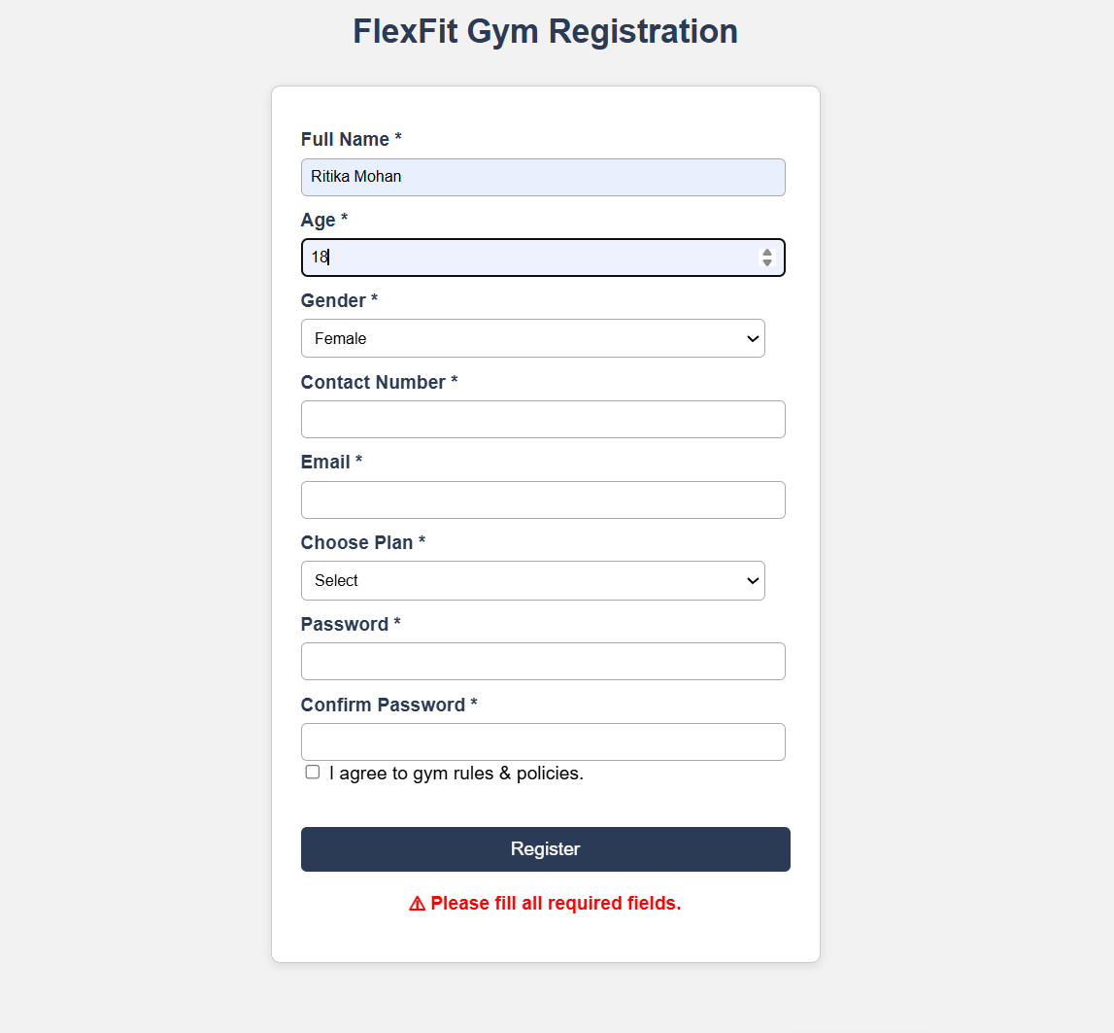
Conclusion: Hence Successfully Implemented events such as onsubmit, onblur, onchange. Built a gym admission form with live validation of inputs like name, email, and age.

